M I N U T E S
from
Monitoring Visit

Date: October 14, 2019
Venue: University of Mostar, Bosnia and Herzegovina

PARTICIPANTS: Selma SETA (University of Travnik); Zora PILIC, Monija MALESEVIC, Milea Ajduk KURTOVIC, Vesna SUSAC (University of Mostar); Marko Antonio BRKIC (Herzegovina University); Mirjana STOJANOVIC TRIVANOVIC (Independent University of Banja Luka); Ljiljana KOVAC (DZPU); Suad MUHIBIC, Dejan ROSIC (National Erasmus+ Office in Bosnia and Herzegovina); Jadranka MIHIC (Delegation of the European Union to Bosnia and Herzegovina)
Agenda of the Meeting:
12:00-12:30
Introduction and overall presentation of the project by project team members of the Faculty of Science and Education of the University of Mostar
12:30-13:30
Analysis of project activities in comparison to the project work plan
13:30-15:00
Discussion about potential obstacles and issues related to the implementation of the project activities (procurement of the equipment, accreditation, financial management, etc)
15:00-16:00
Conclusions and recommendations

The meeting officially started at 12.00 pm. Professor Pilic welcomed all participants and wished pleasant stay at the University of Mostar. She started with the project overview presentation. She explained the most important facts on project and its implementation. She listed what so far was developed within the Curriculum Development aspect. She shorty present the activities implemented by the representatives from the University of Mostar.

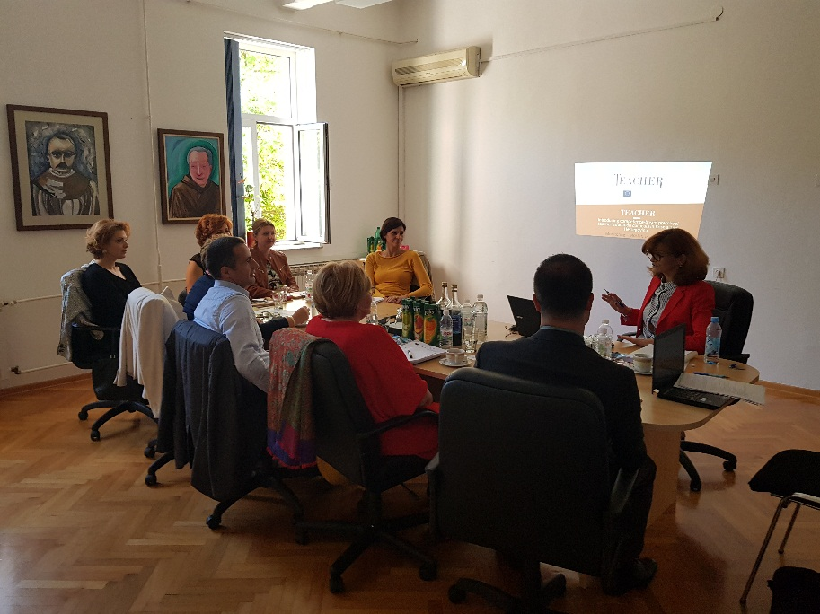

After her overview presentation and short description of the project, Selma Seta presented the Work Plan for first, second and third year of the project implementation. Her focus was on first and second year, due to the fact that only several activities were implemented in third year of project implementation.

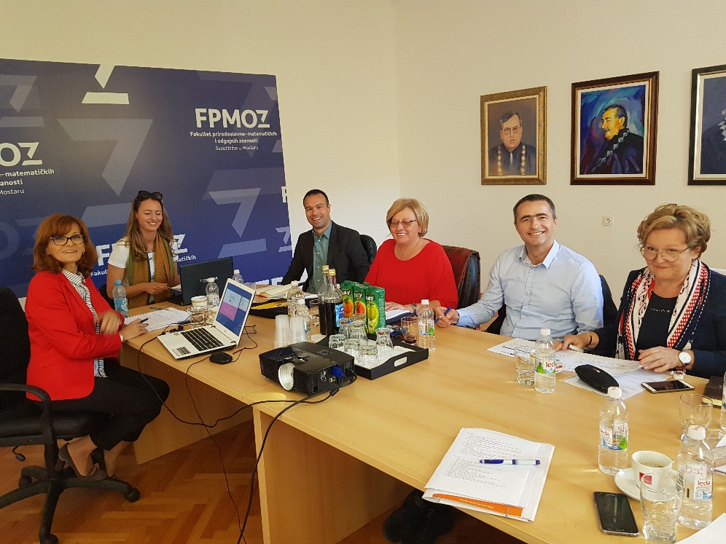

She explained overall procedure of the accreditation problem which affected the TEACHER project. All meetings between BH project partners, and with the authorities on this problem were presented. However, the overall conclusion was based on the request for project extension and its approval.
After those two presentations, participants had a long discussion which was mostly based on the Accreditation of the Preschool Curriculum. This was stated as the external, policy issue, which could not be resolved by project consortium.
However, the implementation of the TEACHER project was assessed as a good one, so far. Project consortium work so hard, had a lot of local project meetings, as well as, meetings with the Ministry of Civil Affairs and all other relevant ministries. They wrote several letters to the relevant authorities including the Agency for Development of Higher Education (HEA), and their contribution to the resolving of the accreditation problem reached its maximum. They did everything in their power.

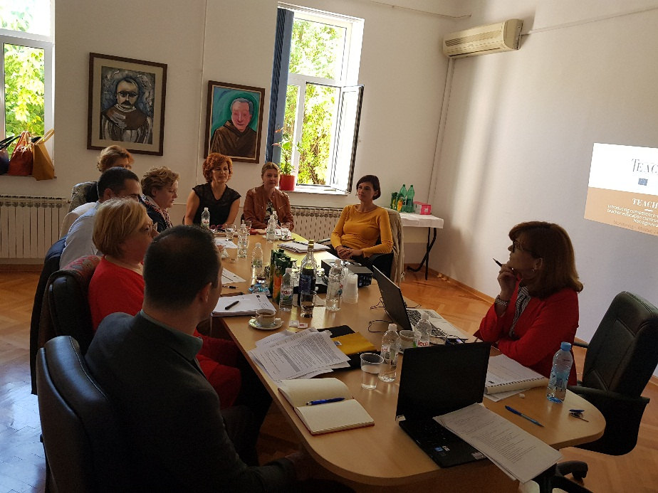
At the end, point was on the future steps within the project implementation. The following conclusions were made:
- Urgent work on accreditation procedure and equipment purchase (prepare all documents necessary for tender procedure)
- In the next year be focused on the IMPACT, DISSEMINATION and SUSTAINABILITY. (The expected impact of the TEACHER project on the community and stakeholders. Work as much as possible on dissemination and spread the project results as far as it is possible. The accreditation is one of the most important aspect of the project sustainability, so this should be resolved soon.)

Minute taker: Selma Seta

